# Custom Geomaps Luxemburg for Visual Analytics 7.5

The map polygons used in this document can be found on the Public data portal of Luxembourg

<https://data.public.lu/en/datasets/limites-administratives-du-grand-duche-de-luxembourg/>

<https://download.data.public.lu/resources/limites-administratives-du-grand-duche-de-luxembourg/20200609-102703/limadmin-shp.zip>

This Shape file is stored in the Coordinate System of Luxembourg: Système de coordonnées LUREF EPSG:2169.

SAS Visual Analytics 7.5 uses: ESPG: 4326 or WGS84 as default projection.

In SAS Visual Analytics 8.x you can also use other projections like EPSG:2169.

In order to change the projection, I have opened the Shape files in qGIS:

1. Check the layer properties if they reflect the correct Encoding (UTF-8) and Projection (ESPG2169)

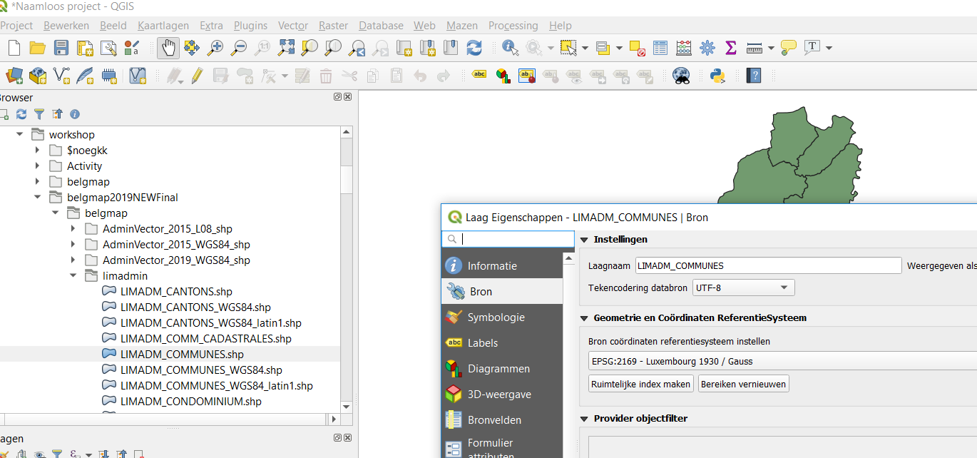

1. Save the map layer to a new Shape file that you can import with SAS: LIMADM_COMMUNES_WGS84_UTF8.shp

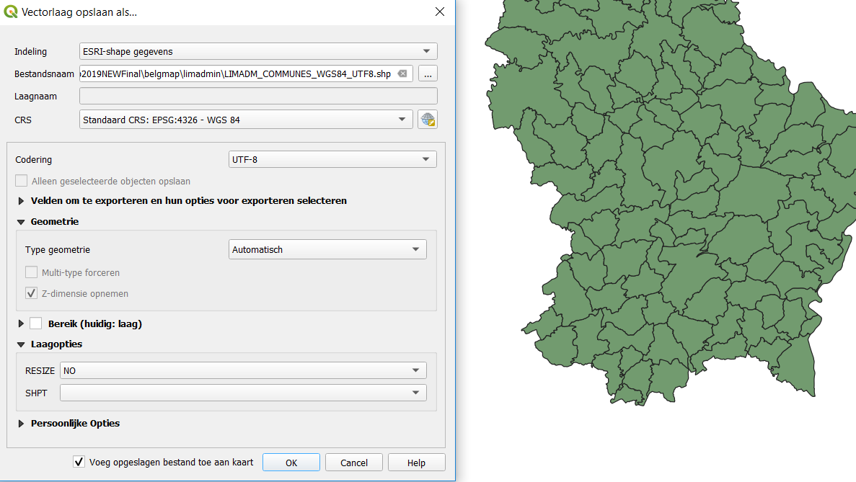

## Import the LUMAPS in your SAS 9.4 environment:

1. Unzip le lumapsv2_20200618.zip to the folder d:/workshop/lumap (or another folder)
2. The folder should contain the limadmin, sasdata, sascode folder
3. Open the MasterScriptLU.sas in EG or SAS Studio (or open the GEOLUMAP EG Project)
4. Adapt the macro variables:
   1. path macro variable so it corresponds to the location where the folders above can be found.
   2. Encoding macro variable so it corresponds with latin1 or utf8 (two versions of Shape files that contain the map polygons) important for the commune where you have accents
5. Create in the SAS Config directory the MAPSCSTM Library:

Open the appserver_autoexec_usermods.sas (make a backup copy first, just in case).

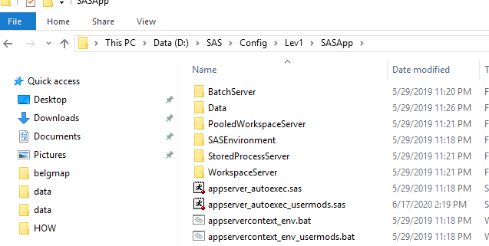

Insert the following code to assign the MAPSCSTM library at startup of the SASApp server:

/*Custom MAPS library for SAS Visual Analytics*/

libname mapscstm "D:\workshop\lumap\sasdata";

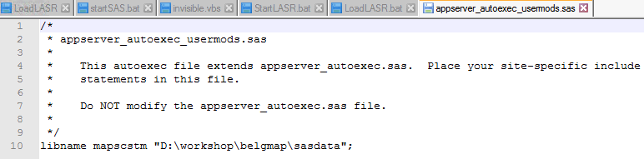

1. Make a backup of the tables in valib: ATTRLOOKUP and CENTLOOKUP (there is one in the MAPSCSTM (from a windows environment, latin1)
2. Run the MasterscriptLU.sas on your SASApp server.
3. This script will update the ATTRLOOKUP and CENTLOOKUP datasets

## Using the maps in a VA Report:

Municipality map: I’m using LAU codes (Local Area Unit – LAU2) from Eurostat.

All LAU Codes start with a non-existing 2 letter abbreviation: ZL-

Join your Municipalities to the MAPCSTM_MUNLU1_TEST dataset to lookup the correct codes to use.

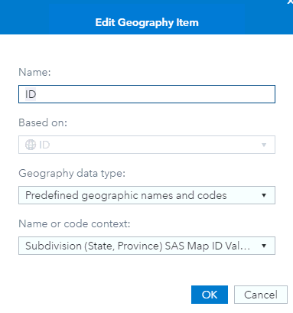

I have included a sample datasets: CUSTOMLU1_POPAREA with population and Area of the Municipalities.

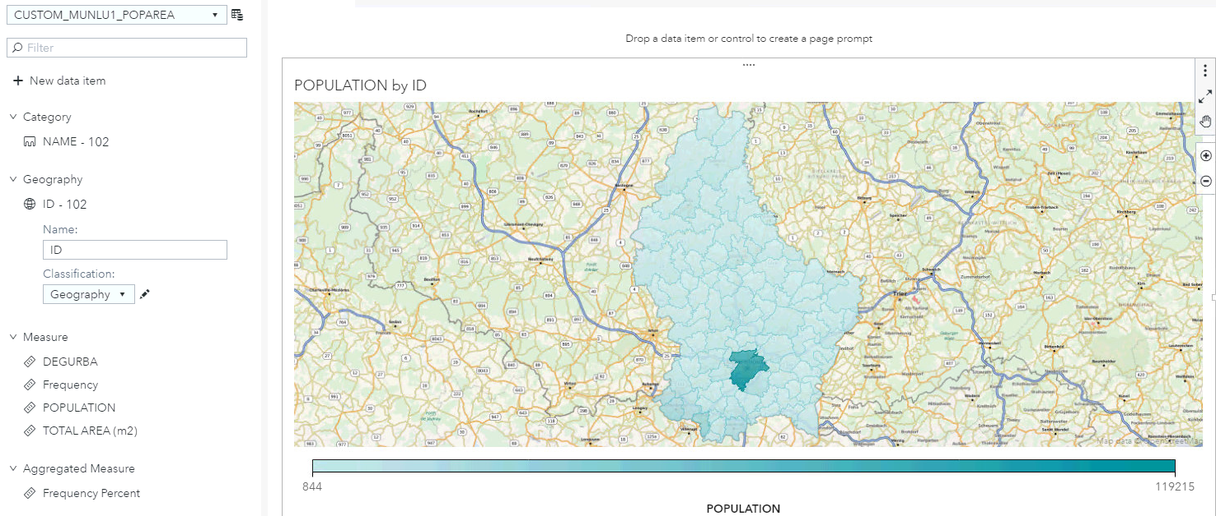

Cantons:

I’m using the LU-CA (ISO 3622) codes for the Luxemburg cantons

LU-CA Canton Capellen

LU-CL Canton Clervaux

LU-DI Canton Diekirch

LU-EC Canton Echternach

LU-ES Canton Esch-Sur-Alzette

LU-GR Canton Grevenmacher

LU-LU Canton Luxembourg

LU-ME Canton Mersch

LU-RE Canton Redange

LU-RM Canton Remich

LU-VD Canton Vianden

LU-WI Canton Wiltz

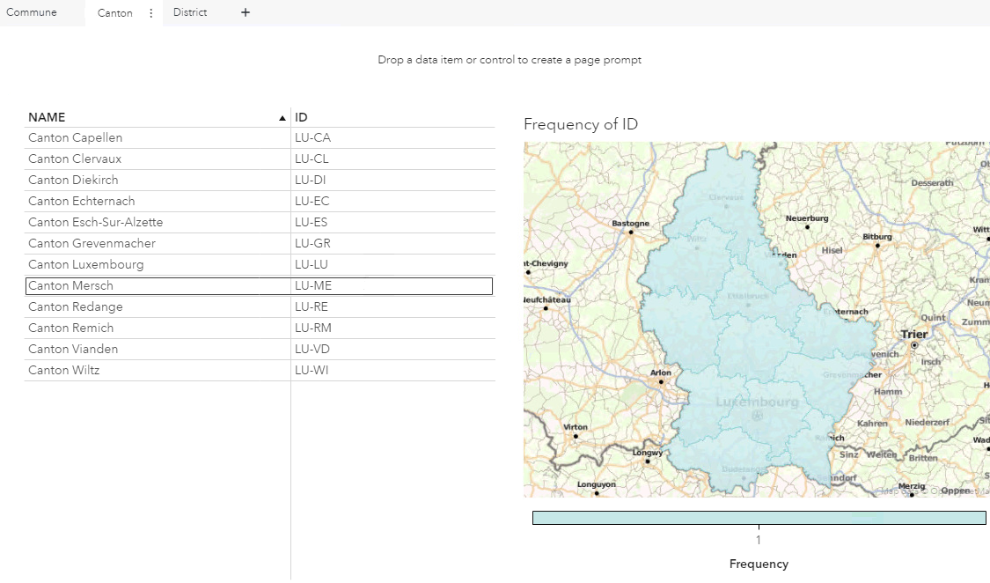

District: abolished in 2015. I have created 3 ids that are fictive: ZD-1, ZD-2, ZD-3.

